BRENTWOOD HISTORIC COMMISSION
HISTORIC MARKER AND SIGN GUIDELINES, APRIL 2026
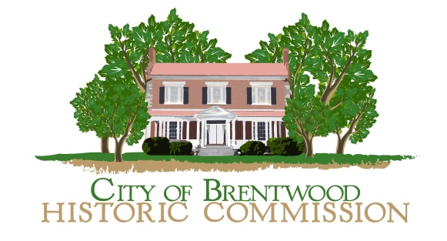
- Purpose: This document provides information and guidance to Brentwood Citizens interested in having the BHC (Brentwood Historic Commission) install a marker (sign) on a site or cemetery determined by the City Commissioners to have historic significance. Criteria for this determination is provided by City Ordinance Section 2-182. Questions should be directed to the Historic Marker Committee Chairperson or City Staff member identified on the BHC webpage.

- Styles: There are different styles of signage used by the BHC. The most common for sites and cemeteries are black signs with white lettering. These are between 18 and 19 inches wide and of a height to accommodate the text. They are generally hung from a black painted, steel, custom pole. Other signs include Landscape Signs, interpretive signs that vary in size and design, plaques and other markers.

- Signs: These are made from 6-millimeter thickness aluminum diebond. This material is very strong and holds up to the weather.

- Posts: Posts are custom made of structural steel and painted black.

- Historic Cemetery Installation: While use of custom posts is preferred, signs may be hung on fence railings with black chain.

- Paying for the signs and posts: The BHC budgets for new signs, posts, installation and repair. If a property owner asks for additional information and custom printing, then reimbursement to the BHC may be requested. Contributions are appreciated.

- Maintenance and Repair: The BHC maintains markers that it originally installed.

- Examples of various signs are provided below:
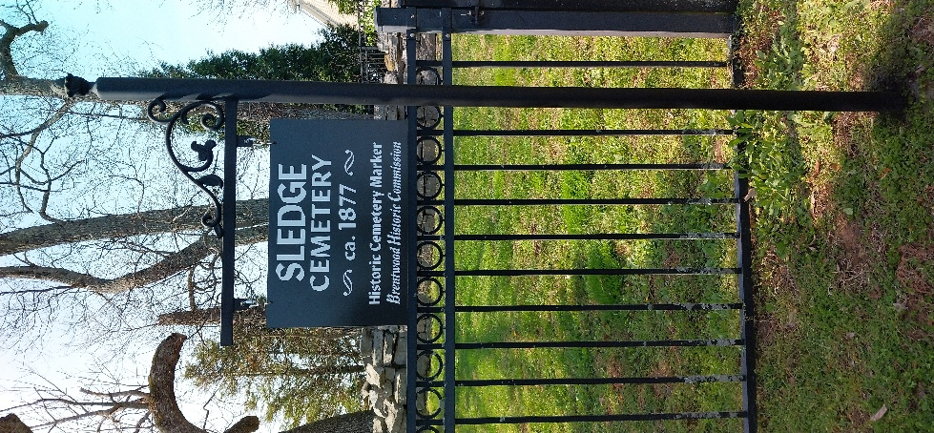 | 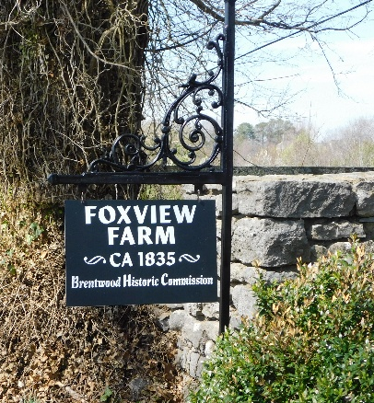 | 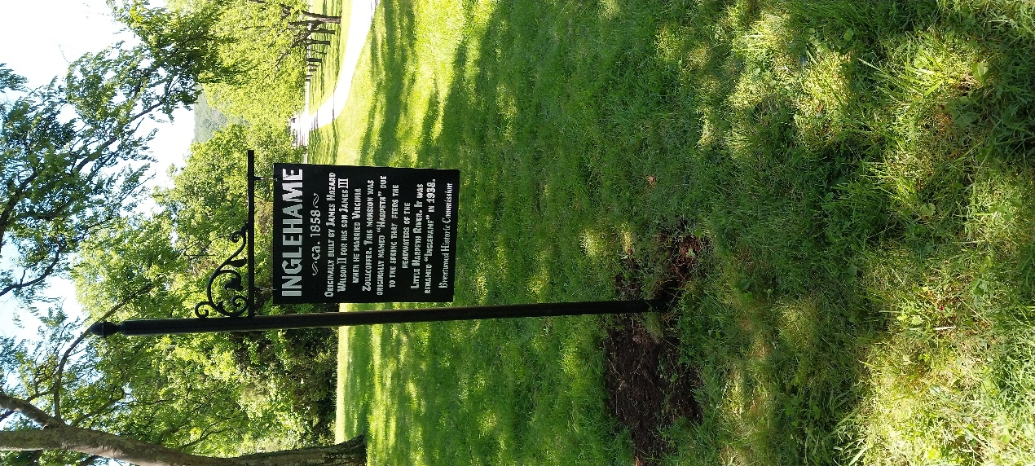
Cemetery Marker  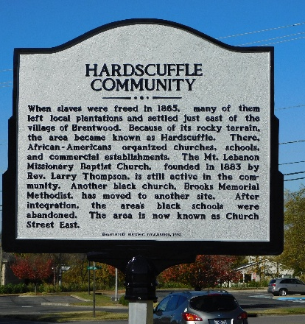 | Site Marker  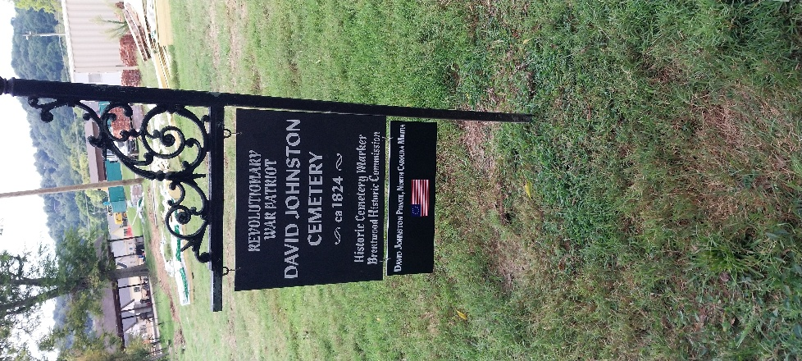 | Custom Site Marker  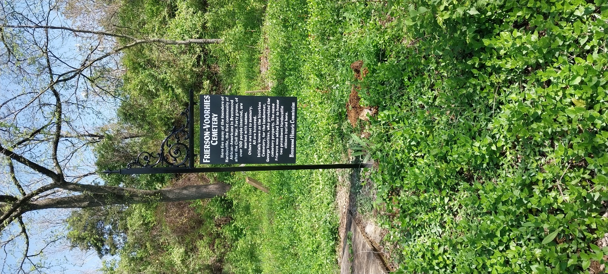
Landscape Sign  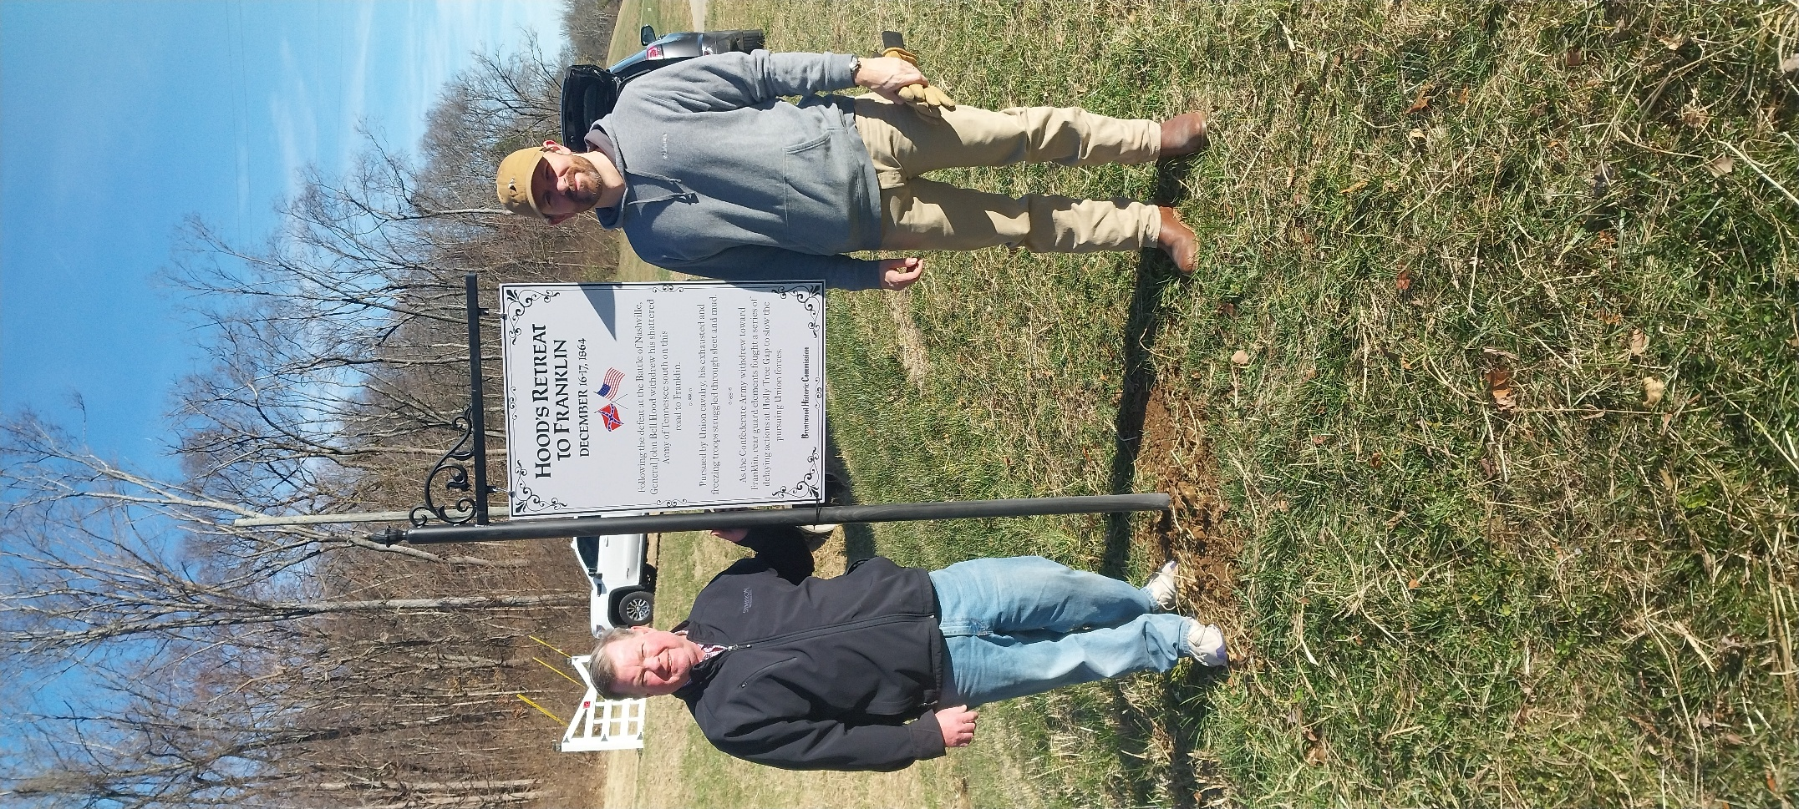 | Patriot Cemetery Marker  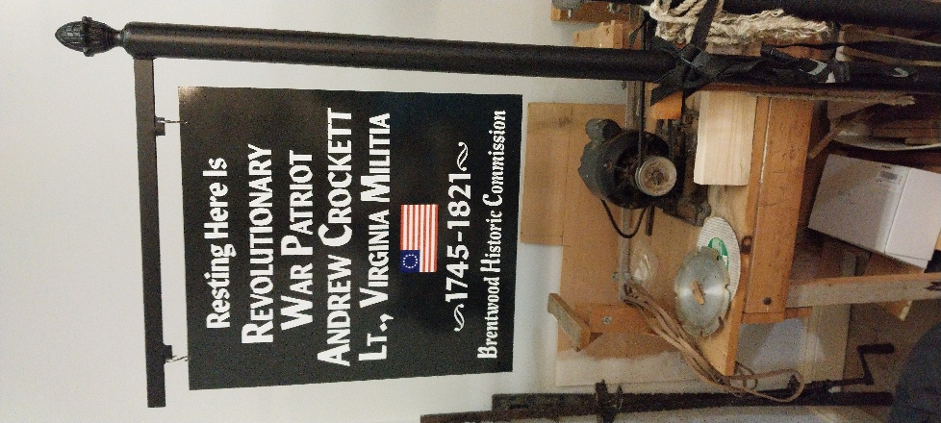 | Interpretative Cemetery Marker  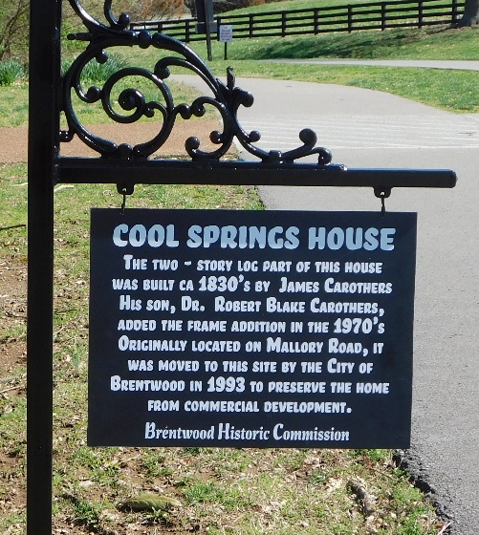

Historic Event Sign Custom Patriot Marker Interpretative Site Marker

